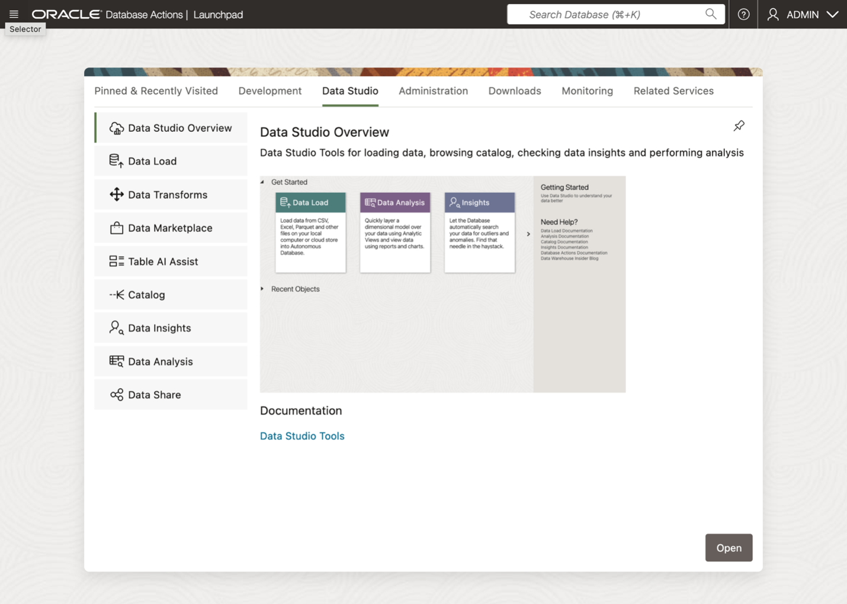
create-data-product-share-1.png

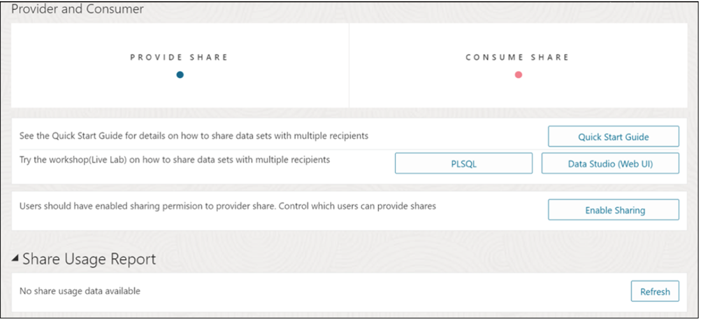
create-data-product-share-2.png

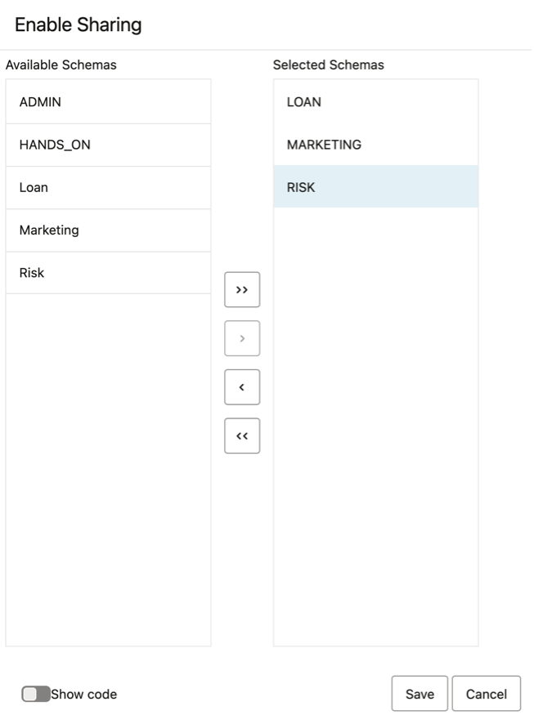
create-data-product-share-3.png
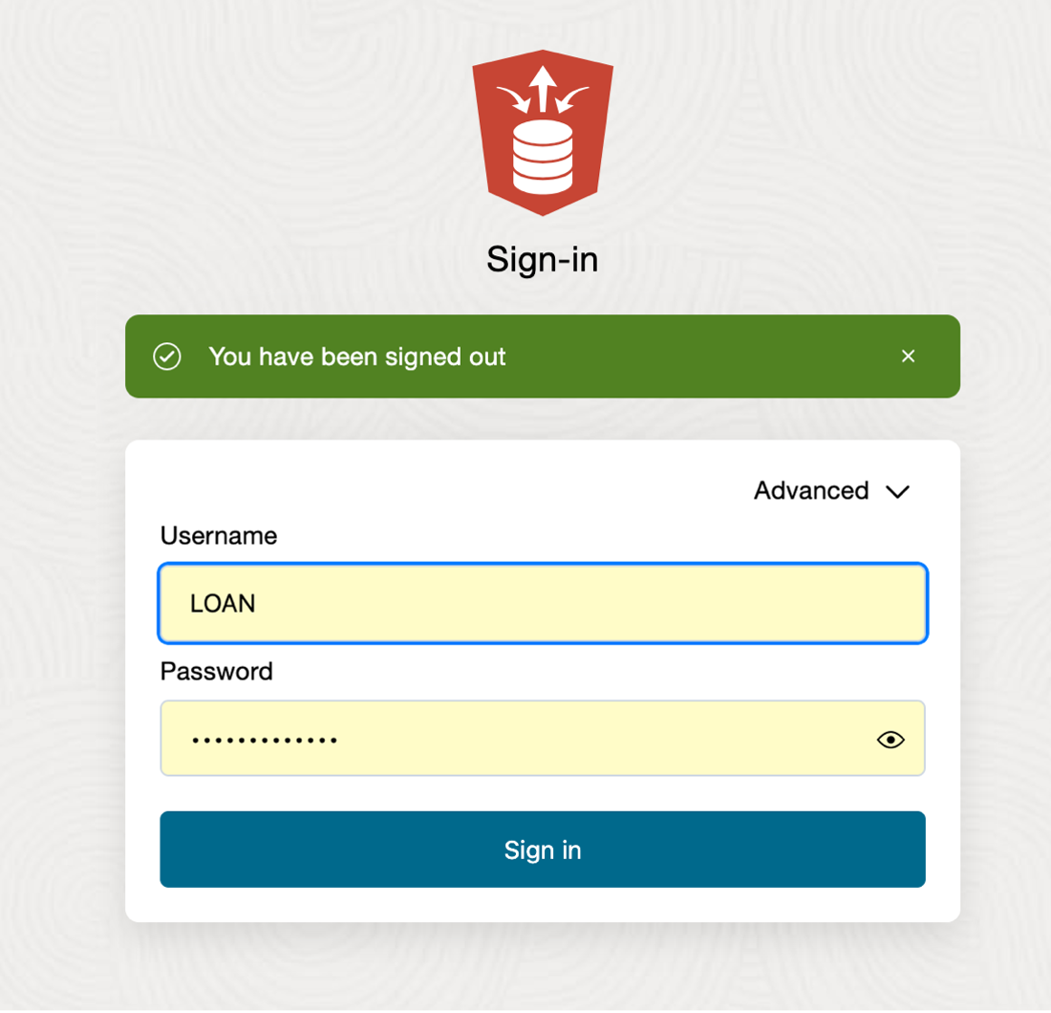
define-data-product-share-recipient-1.png

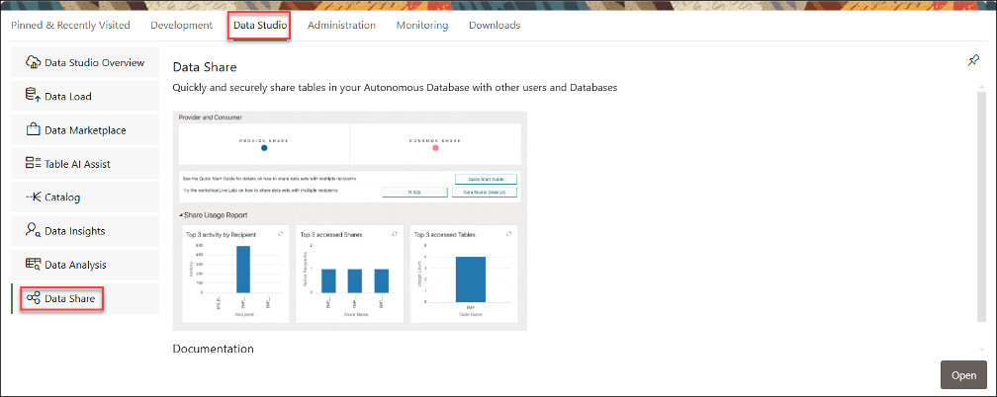
define-data-product-share-recipient-x.png
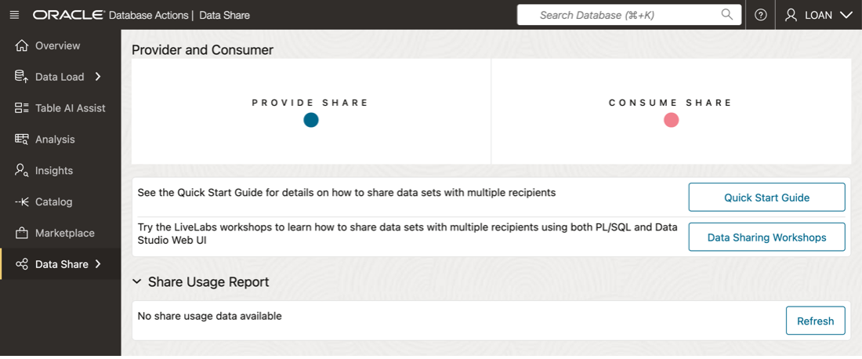
define-data-product-share-recipient-3.png

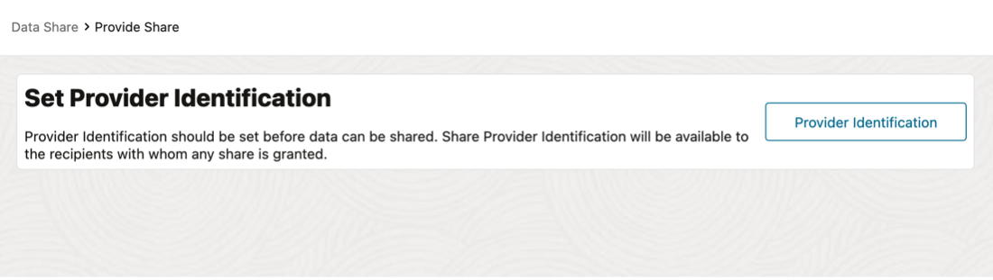
define-data-product-share-recipient-4.png

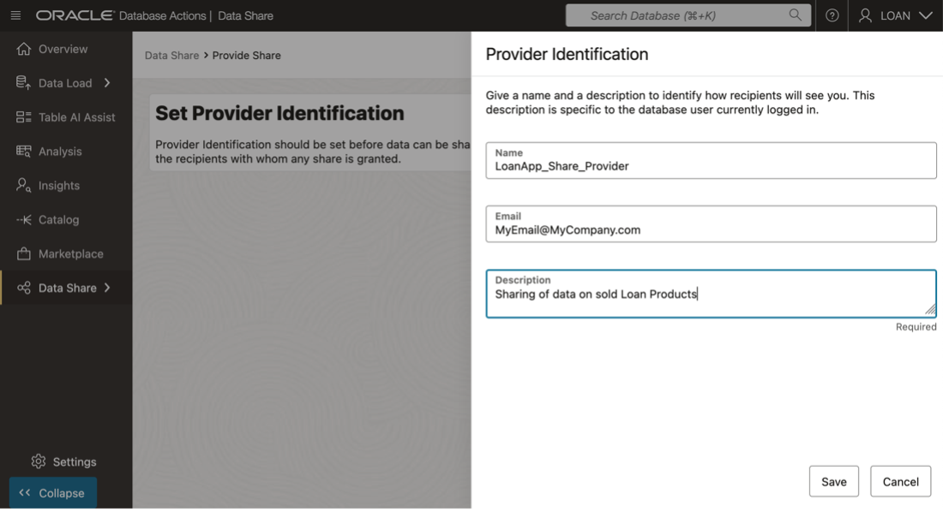
define-data-product-share-recipient-5.png
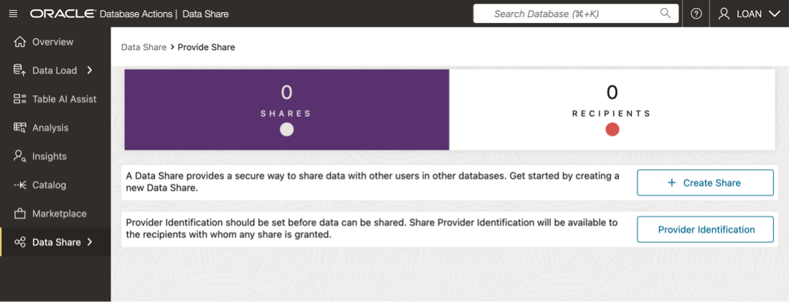
define-data-product-share-recipient-6.png
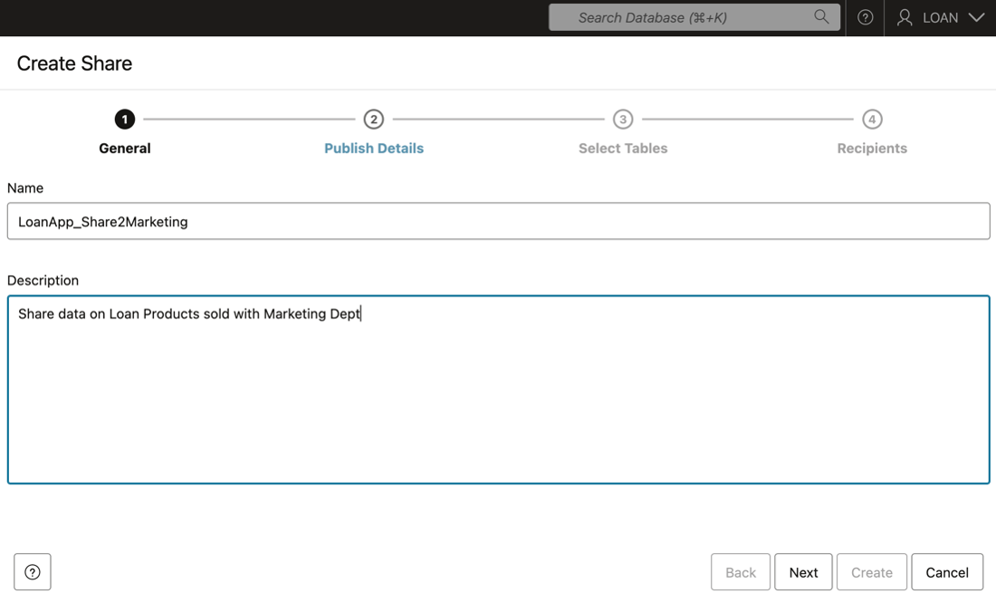
define-data-product-share-recipient-7.png
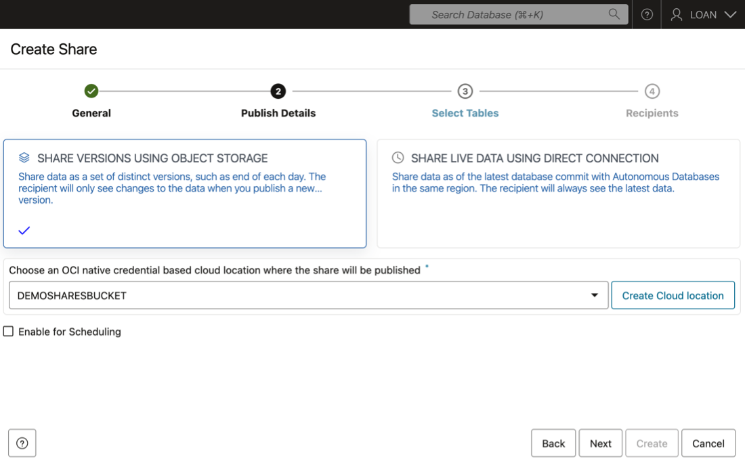
define-data-product-share-recipient-8.png
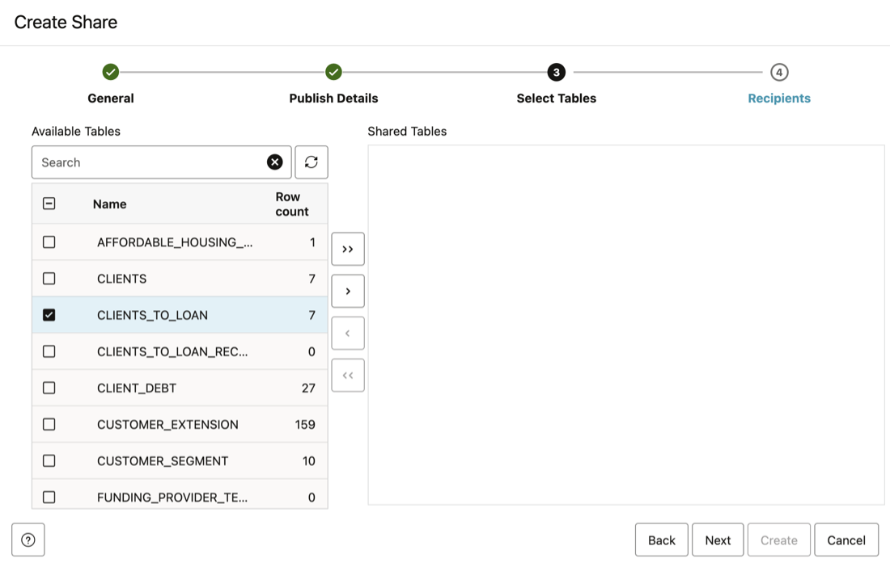
define-data-product-share-recipient-9.png

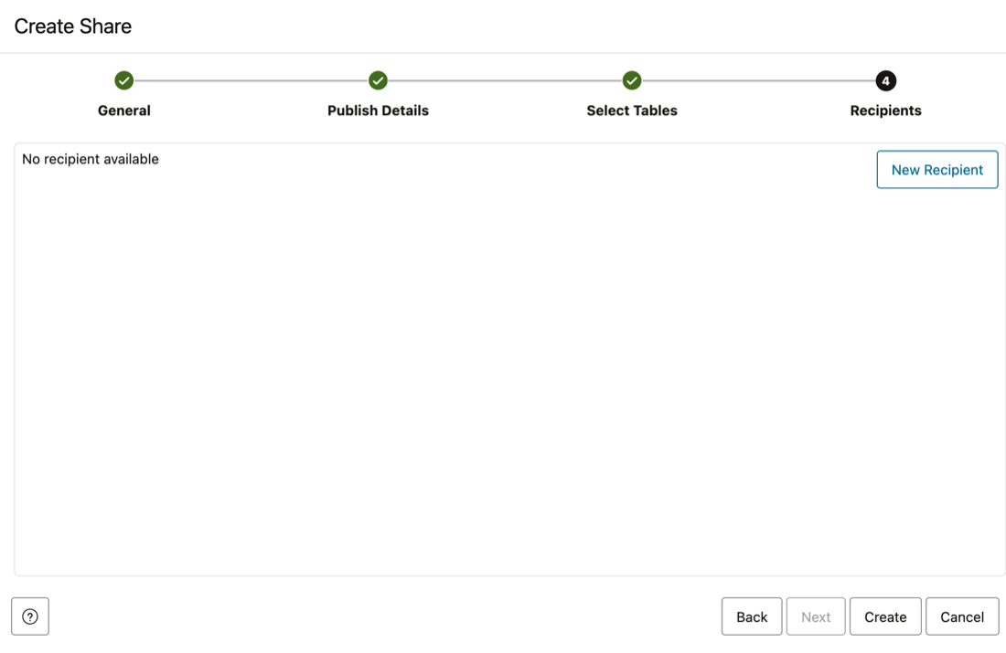
define-data-product-share-recipient-10.png

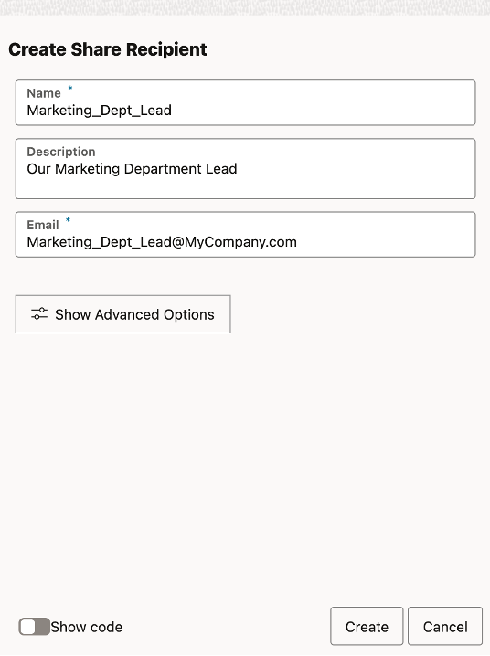
define-data-product-share-recipient-11.png
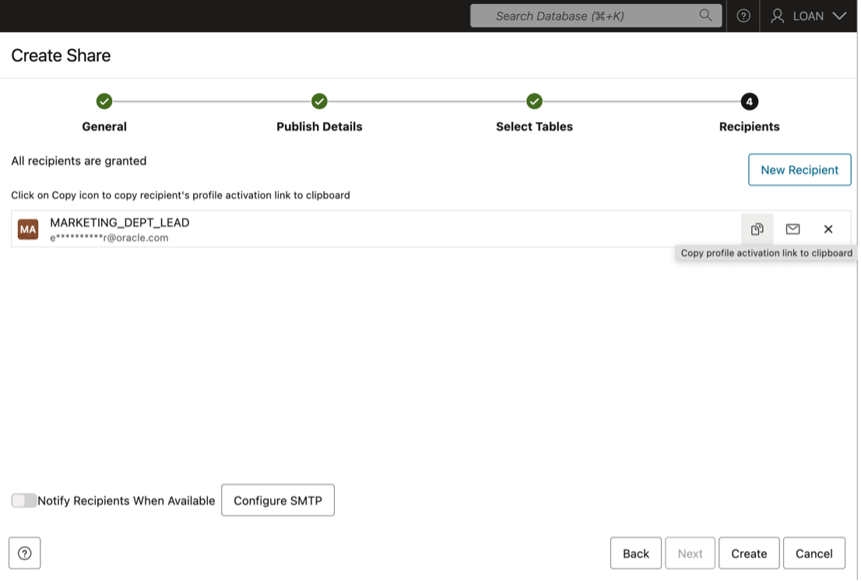
define-data-product-share-recipient-12.png
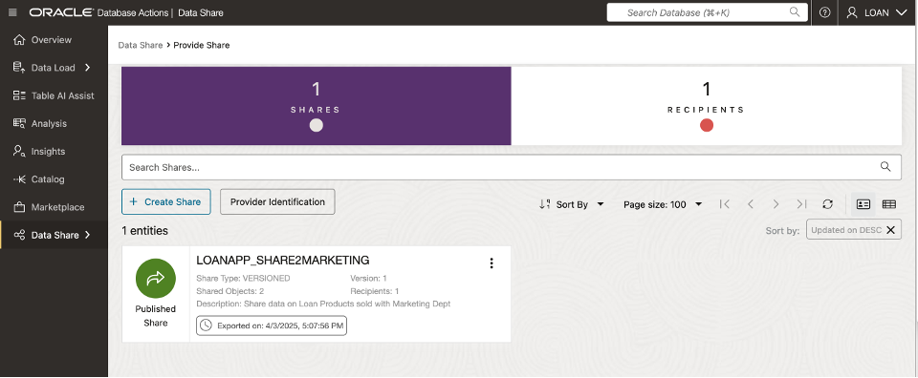
manage-data-product-share-1.png
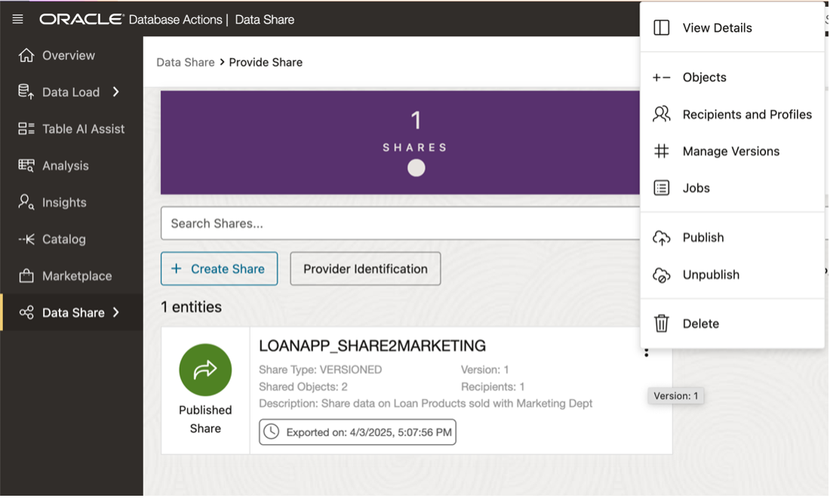
manage-data-product-share-2.png
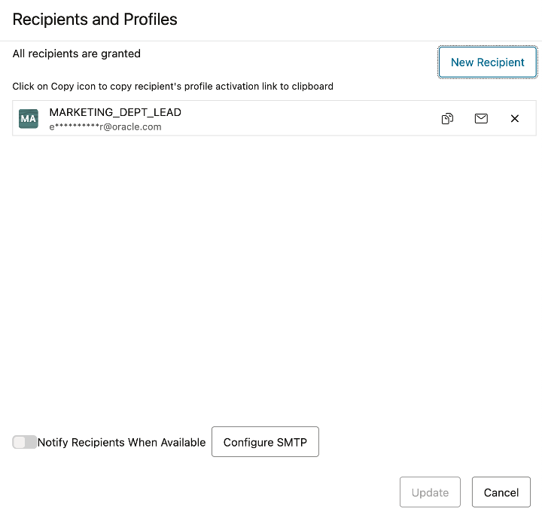
manage-data-product-share-3.png
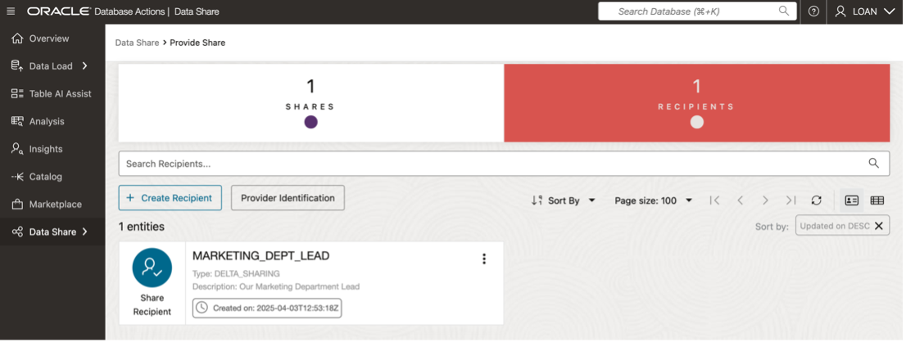
manage-data-product-share-4.png

